skolmaterial

Mina första spanska ord om Skolmaterial

C:\Users\Erika\AppData\Local\Microsoft\Windows\Temporary Internet Files\Content.IE5\FLBYMTZJ\MC900305511[1].wmfCuaderno Block eller häfte

C:\Users\Erika\AppData\Local\Microsoft\Windows\Temporary Internet Files\Content.IE5\RUWQPXOJ\MC900413638[1].wmfpenna lápiz

C:\Users\Erika\AppData\Local\Microsoft\Windows\Temporary Internet Files\Content.IE5\712F1MDD\MC900411862[1].wmf kulspetpenna boligrafo (man kan inte sudda)

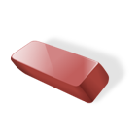goma suddgummi

C:\Users\Erika\AppData\Local\Microsoft\Windows\Temporary Internet Files\Content.IE5\712F1MDD\MC900290924[1].wmfregla linjal

C:\Users\Erika\AppData\Local\Microsoft\Windows\Temporary Internet Files\Content.IE5\712F1MDD\MC900412396[1].wmfbok libro

C:\Users\Erika\AppData\Local\Microsoft\Windows\Temporary Internet Files\Content.IE5\9SA62G4L\MC900232723[1].wmfregla, låpiz y goma

C:\Program Files (x86)\Microsoft Office\MEDIA\CAGCAT10\j0285750.wmfOrdenador dator

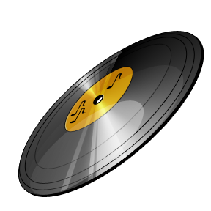CD skiva Disco cd

C:\Users\Erika\AppData\Local\Microsoft\Windows\Temporary Internet Files\Content.IE5\RUWQPXOJ\MC900199871[1].wmfMapp carpeta

C:\Users\Erika\AppData\Local\Microsoft\Windows\Temporary Internet Files\Content.IE5\712F1MDD\MC900360594[1].wmf Kommande spel mando para juegos

C:\Users\Erika\AppData\Local\Microsoft\Windows\Temporary Internet Files\Content.IE5\RUWQPXOJ\MC900088880[1].wmfdatorspela juegos de video

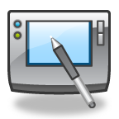surfplatta tableta o tablet

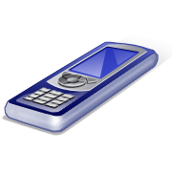Mobiltelefon teléfono móvil